Compiler Software Design
Version 1.0
CSC 450
Alfonso Vazquez

Table Of Contents

1.0 Main Designed …...............................................................................................................................1
2.0 Scanner …...........................................................................................................................................1
3.0 Parser …..............................................................................................................................................3
3.1 Grammar ….............................................................................................................................3

1.0) Main Design

This Design Consist of different Sections explaining how the compiler from simple Pascal to MIPS assembly. The compiler only has the first two parts of the whole series implemented; both scanning a file and parsing a file are successful. This parse only deals with ASCII characters anything in UNICODE will not be scanned nor parsed.

2.0) Scanner Design

The Lexeme list was the first part of the design for this project. The lexeme list came out of the grammar (provided by Prof. Steinmetz).

Lexical Units

Q | Reserved Words | Other Units
1 | if | ;
2 | then | .
3 | else | :=
4 | while | [
5 | do | ]
6 | program | (
7 | var | )
8 | begin | +
9 | end | -
10 | array | *
11 | of | /
12 | function | =
13 | procedure | <>
14 | or | <
15 | not | <=
16 | mod | >=
17 | and | >
18 | real | :
19 | integer | ,
20

The Scanner was designed from a Finite State Automata (Drawn with JFLAP). The Finite State Automata overtakes the whole simple Pascal language.
Starting with the 0 state. The 0 state initializes the process: From white space, to comments, to ID, Floating Values and Error state. All the 200's states are final. Instructions on nodes which have square brackets surrounding “[ ]” refers to as a push back the last input to stream (state 0). The Error state indicates to break the input stream, hence if the Automata does not read: Integer, symbol from the lexeme list, letter (ASCII Value 65-90 and 97-122). Or “{“ then it will go to the error state, and terminate.
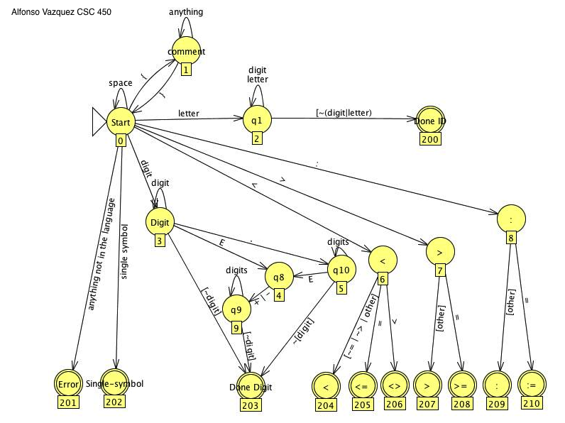

Figure (1).
**Boxes under the states represent the number of the state. This serves for coding purposes.

The scanner implementation:
Constructor takes care of the file read. Scanner has all the states declared as static final integers since they should not be changed unless the above diagram changes. The scanner can accept a token by IS_A_LEXEME, IS_NOT_A_LEXEME, or IS_AN_ERROR. The scanner has an implementation of cases for the input stream to go to. If a token reaches case 201 then the parser implementation is to keep going, since the scanner does not care if the token is accepted. The parser should take care of that.

3.0)The Parser Designed

The parser was implemented from the grammar, which essential is the pseudo code.
The implementation of the parser is to replace λ with an empty else statement returning nothing. As well to match all the current tokens that are been scanned in by the scanner. The parser is the responsible part of the code to error out if a lexeme is not available. The error is then showed, followed by the line number, which still needs to be implemented.

3.1)The Grammar

The grammar is the PDF provided by the professor. It is the document from where the lexeme list was extracted from. As well as where the parser was coded from.

